Version Control

Samuel Cooke – s251388

Repository Link
Link: https://github.com/s251388/AIE-2.2.2-Bubble-Sort.git
Screenshot:
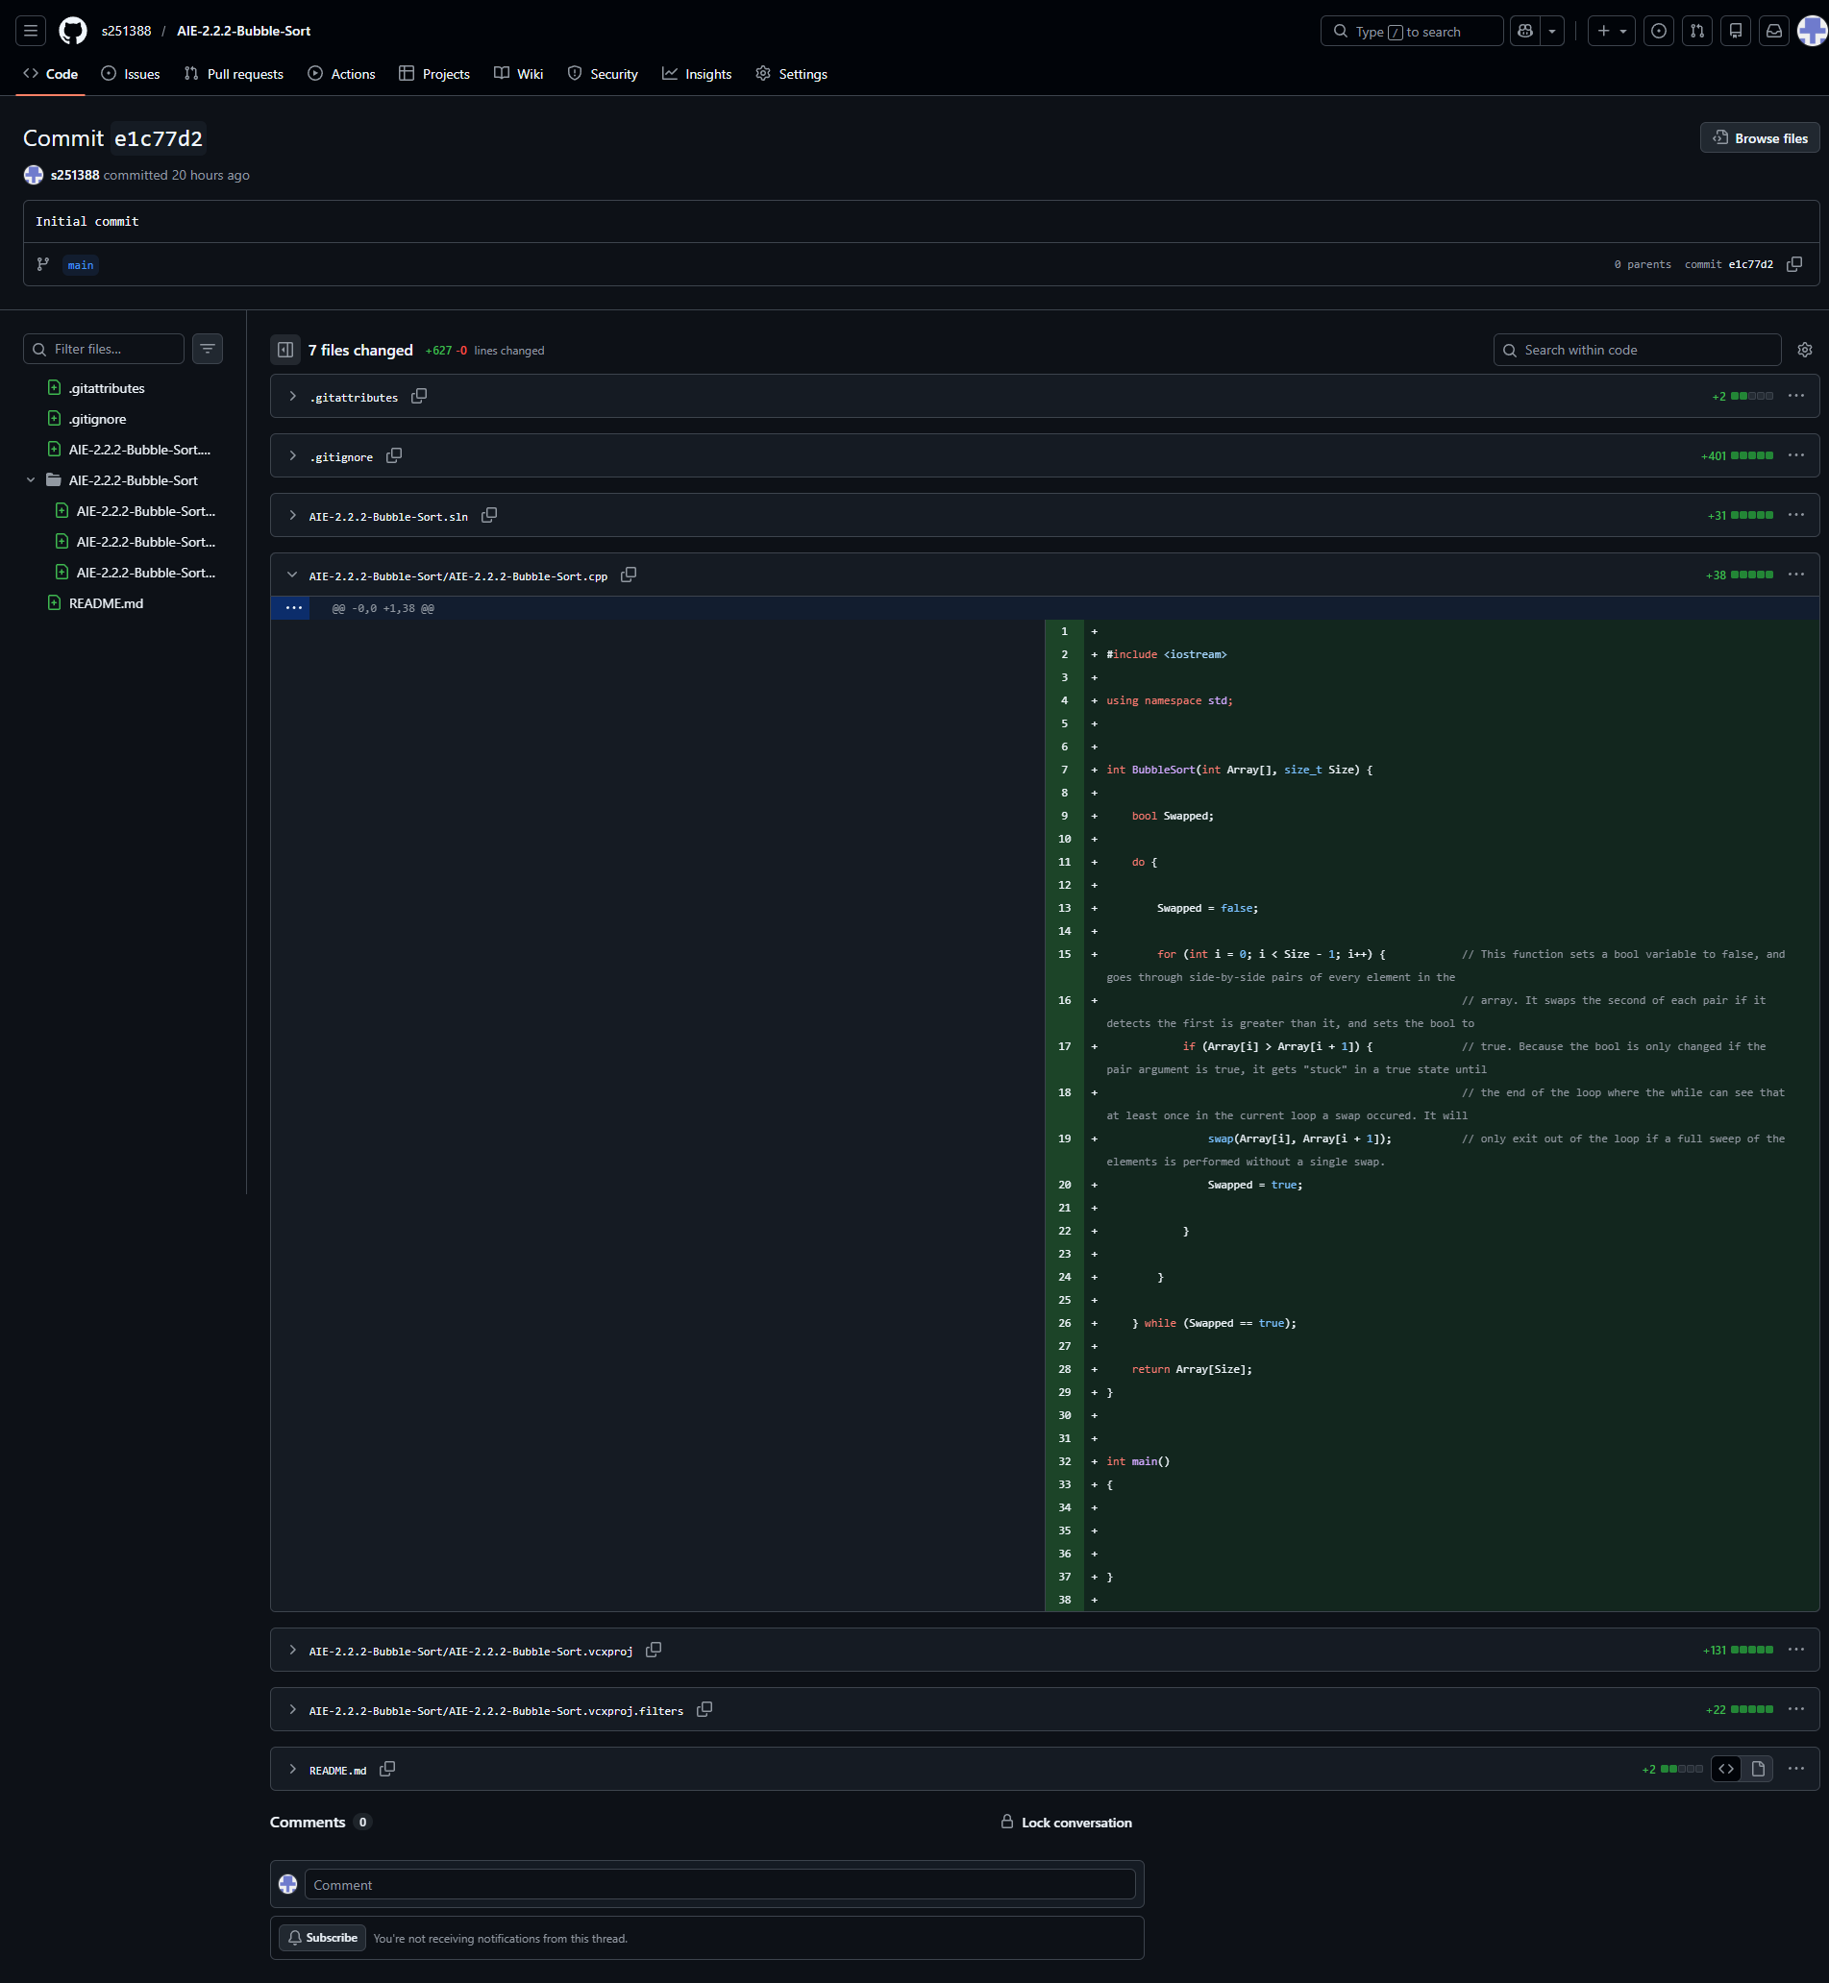
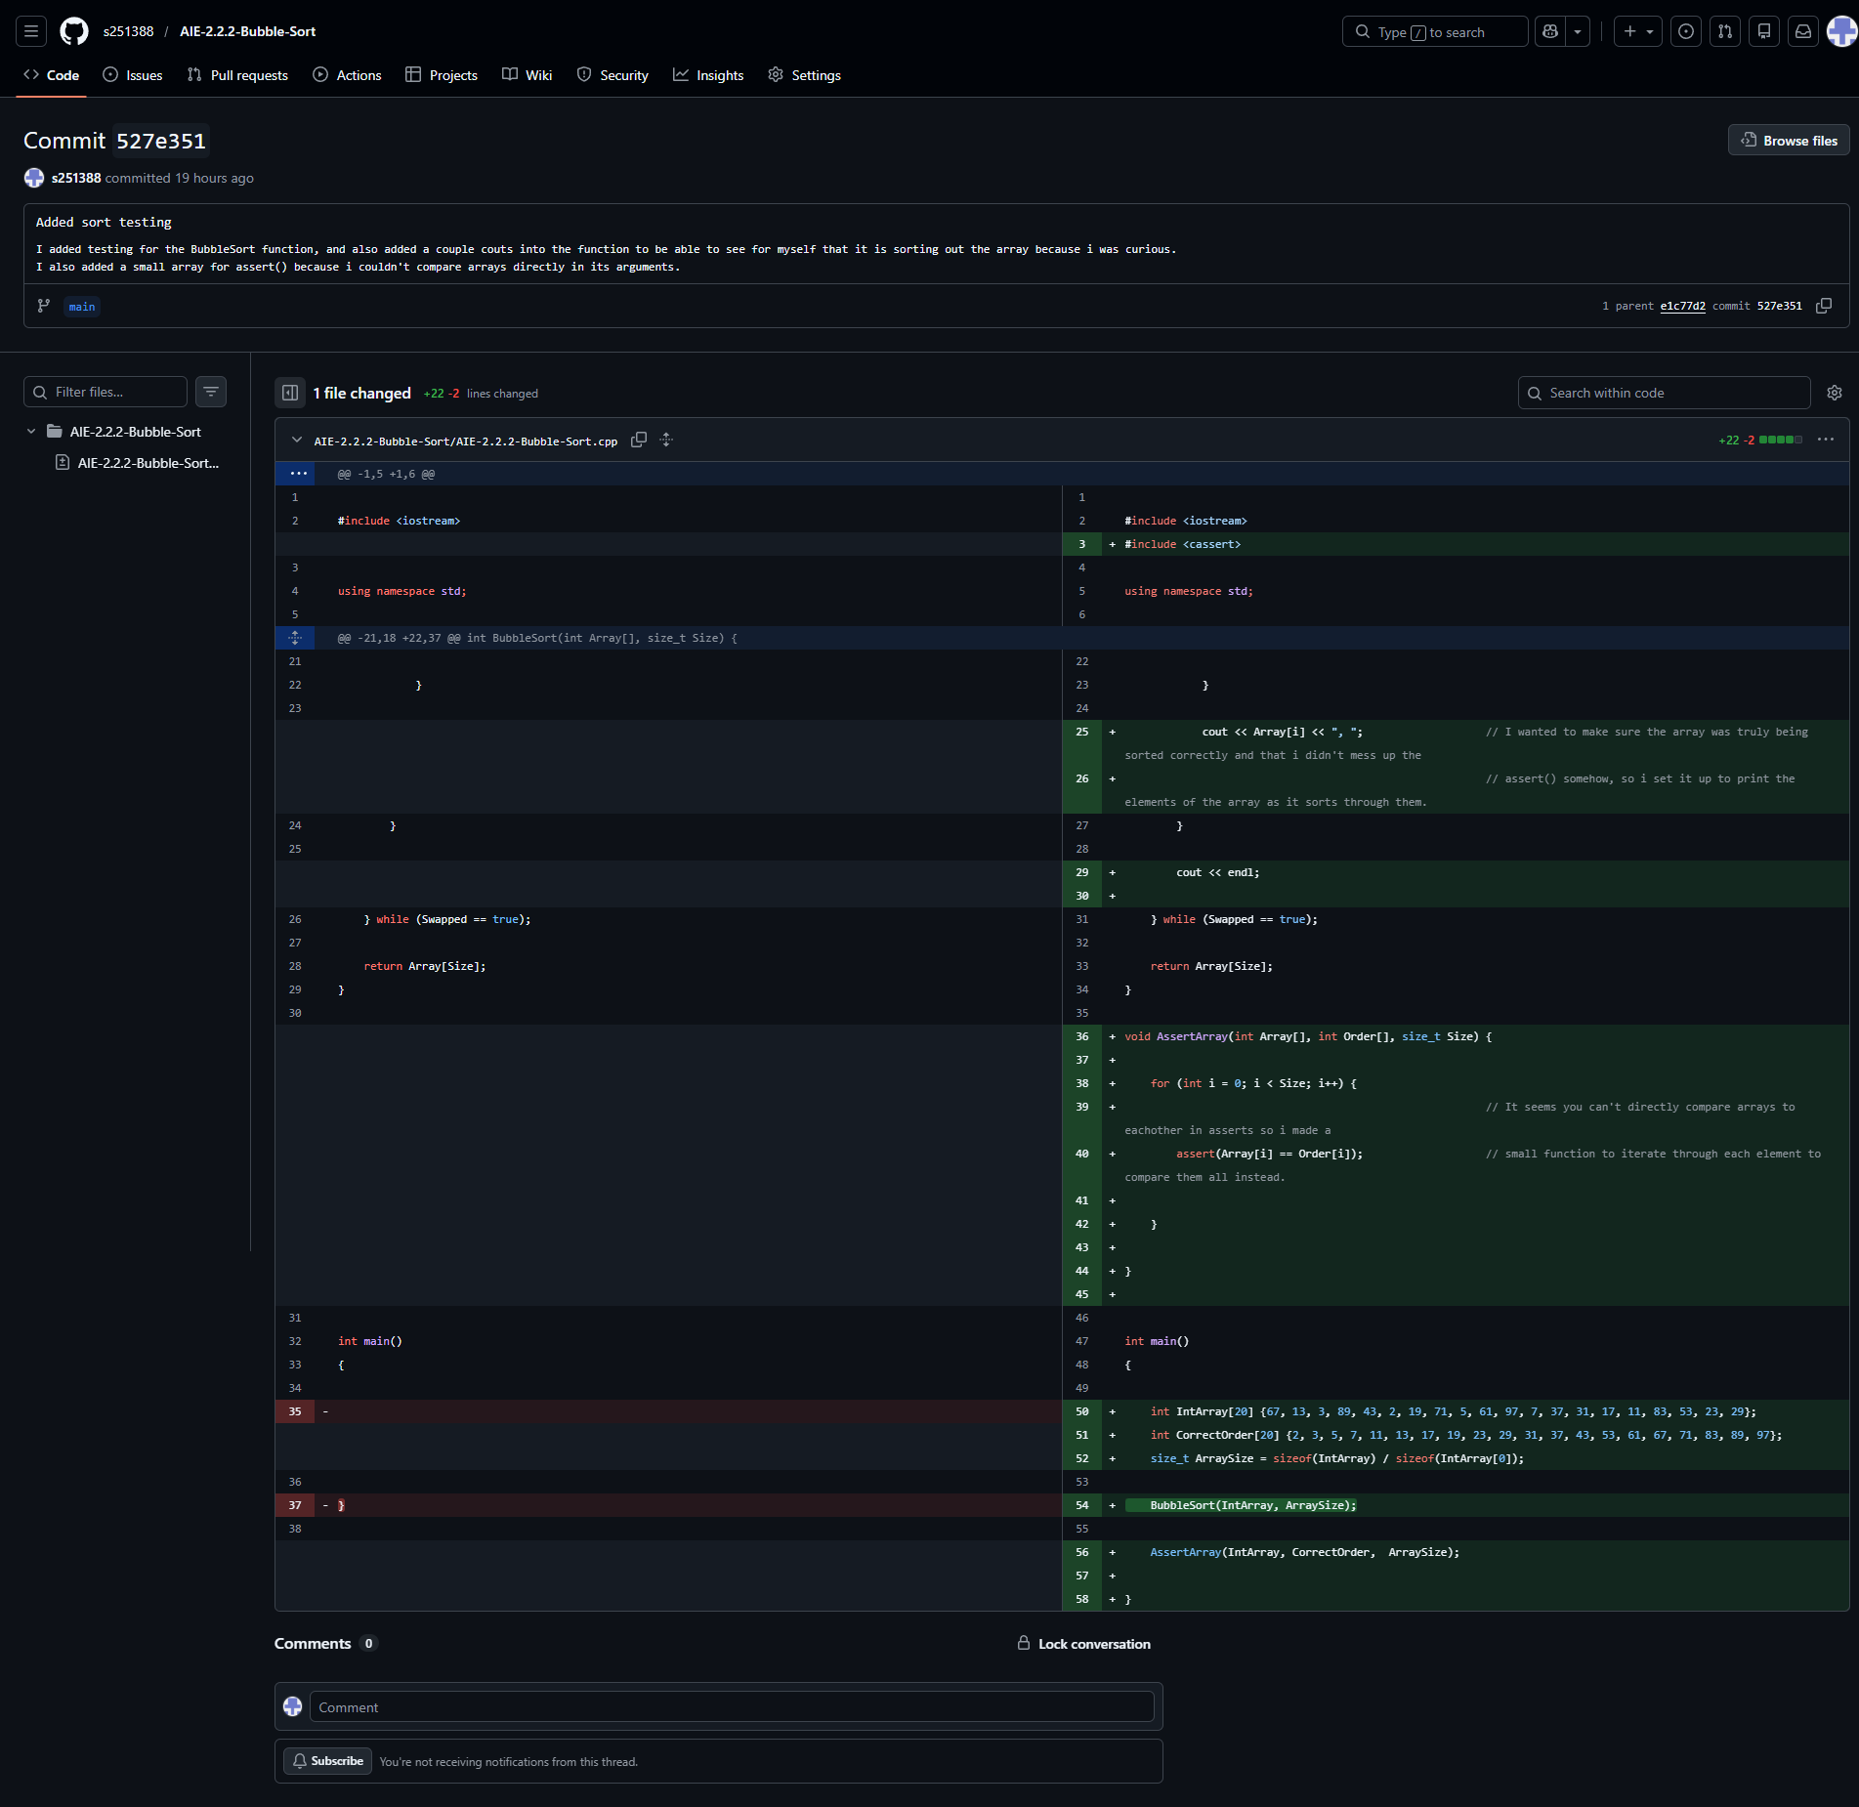

Resources:
- Assessment’s “Bubble Sort tutorial” page (may not be available permanently?): https://aie.instructure.com/courses/1702/pages/introduction-to-c++-bubble-sort-tutorial

Challenges
Write a description of the challenges, mistakes made, or problems you personally encountered, and what you did to overcome, work around, or resolve these issues. (100 - 300 words).
Not many, as soon as i started writing in the code myself i quickly got the hang of what sort of mechanisms the task wanted of me and how to write them.

Weaknesses
Write a list of personal weaknesses regarding version control and ways you could resolve these weaknesses. (100 - 300 words).
Still learning my own coding style, getting more confident with it though.
Reading the example code’s formatting in the task description, i need to learn to better understand code written without the exact correct syntax, stuff like “end if” and “end for” confused me for a while at first but i now realise these kinds of terms are used here in place of {curly brackets} to indicate the scope of a portion of the code.
